Experiment 4

SHOBBIKA T 240701502

Create a prototype with familiar and unfamiliar navigation elements. Evaluate ease of use with different user groups using proto.io

Screen 1:

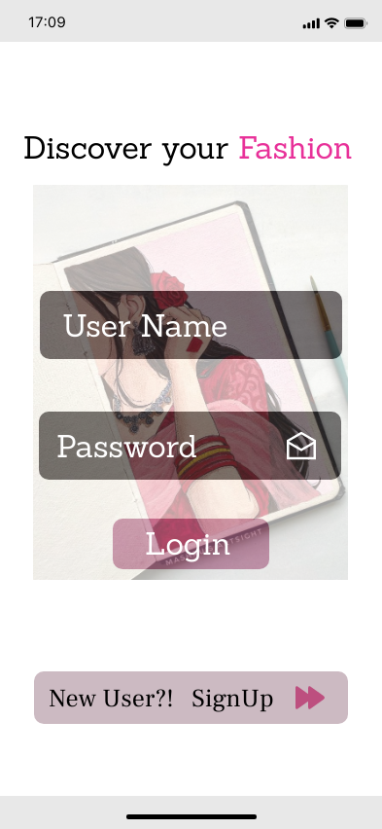

Unrecognizable icons:

- The mail letter icon : Usually we used to have an eye like icon for the password display but here we have used this mail letter icon to display the password. When the letter cover icon is closed the password won’t be visible and if it’s open the password will be visible.
- The play button icon : Usually we used to have an arrow symbol over there , here I have used the play button.

The users won't know the usage of this icon without proper description.

Screen 2:

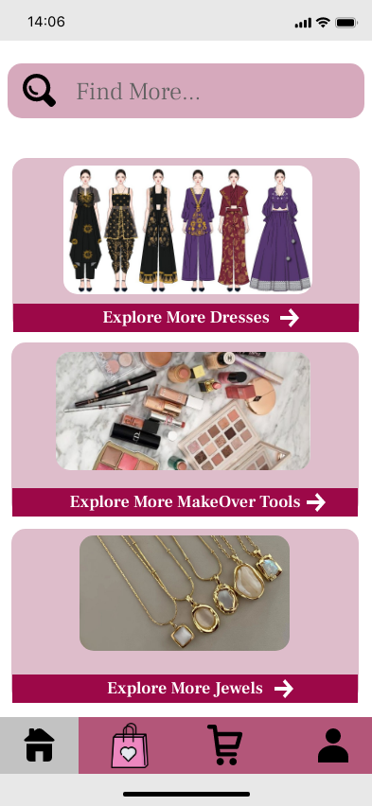

Recognizable icons:

- Search Button: This is the usual search icon used to denote the search bar.
- Arrow icon: Arrow icon is used to denote the explore more part. This arrow icon let’s the user know that they should click the particular part to navigate further.
- Home Button: Home button denotes the common forum of an application where the users can find different features of the application (main features).

Users are capable of recognizing these icons without explanation.

Screen 3:

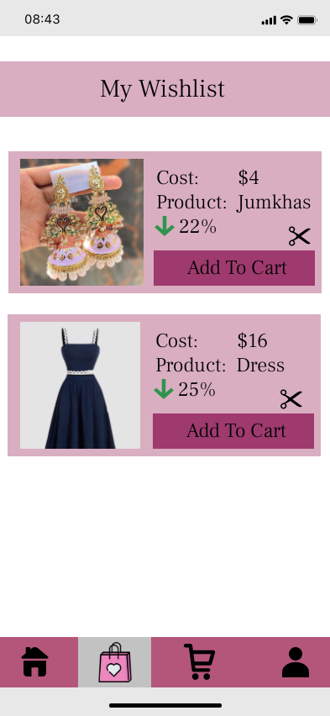

Recognizable icons:

- The arrow down Symbol: The arrow down symbol denotes that there’s a discount for the product and it is familiar.

Users are capable of recognizing these icons without explanation.

Unrecognizable icons:
- The heart bag : The heart bag denotes that it is a wishlist column. Without using a familiar icon for the “items in cart” column the user might confuse this to that.
- The Scissors symbol : The scissors symbol denotes that we can remove the unwanted items from the wishlist. Instead of using the bin icon I’ve used the scissors icon.

The users won't know the usage of this icon without proper description and differentiation.

Screen 4:

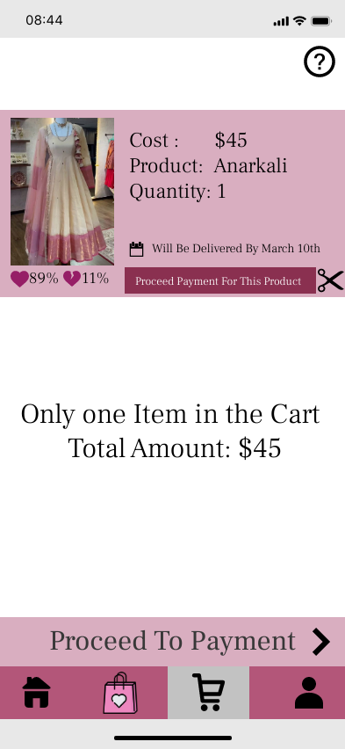

Recognizable Icons:
- The question mark icon: This icon denotes help center and FAQs where the user can find the payment or other enquiries.
- The greater than/ less than symbol : This icon indicates to press the particular button to proceed further.
- The trolley icon : This icon denotes the cart where the items I wish to buy are displayed. From this tab I can verify and proceed further.
- The Calendar icon : This icon is familiar and it denotes the date of arrival of the placed order.

Users are capable of recognizing these icons without explanation.

Unrecognizable Icons:

- The Heart Icon: This icon denotes the number of people who genuinely liked the product. This icon serves as the feedback provider.
- The Broken Heart Icon: This icon denotes the number of people who disliked the product. This icon too serves as the feedback provider.
- The Scissor icon : The scissors symbol denotes that we can remove the unwanted items from the wishlist. Instead of using the bin icon I’ve used the scissors icon.

The users won't know the usage of this icon without proper description and differentiation.

Screen 5:

Recognizable icons :

- The Profile Icon: This icon denotes the profile of the user , which has the user related information. It contains the personal relevant details.
- The menu bar icon: This is the usual menu icon which is either denoted with 3 lines or 3 dots.
- The headphones icon: This icon denotes the customer care services and the help and support services.
- The Call icon: This icon denotes the mobile number and services to reach the customer. Where they can view and edit their contact details.
- The Location icon: This icon denotes the user’s location which they can view and edit before placing the order.
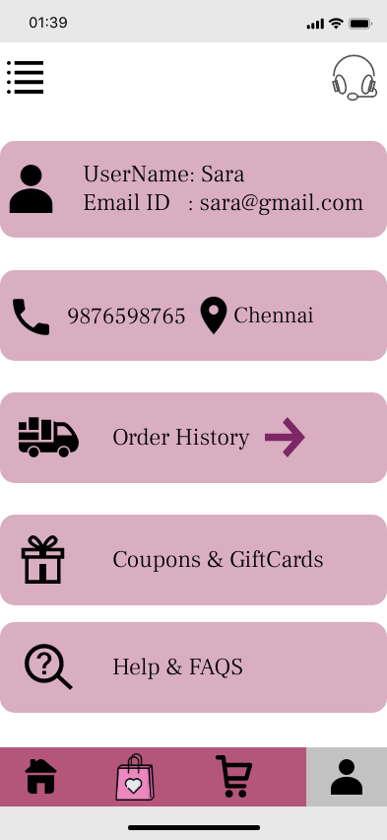

- The gift box icon: This icon denotes the coupons and gift card column , where the user can view their gift card details and expiration.
- The Arrow icon: The arrow icon signifies the "explore more" functionality. Users should click this icon to proceed with further navigation.
- The lens icon with question mark: This icon denotes help center and FAQs where the user can find the payment or other enquiries.

Users are capable of recognizing these icons without explanation.

Prototype Link: https://pr.to/PYRKSC/

